Occupant
Position Sensing
Behind the headlines about variable-force air bag deployment, Torsional Sensing Load Cells are providing accurate occupant position information to solve this important puzzle.
Bob Bruns, GageTek
Place Torsional Sensing Load Cells (TSLCs) on the corners of an automobile’s seat frame, and you can get accurate information not only on the weight of the passenger but also (by calculation of the centroid) on the passenger’s position. This information can be used to reduce the air bag deployment force for children, small statured individuals, and out-of-position occupants. The design of TSLCs lets the manufacturer optimize the devices to provide high output from normal forces and to give them the strength to withstand the orthogonal force that may occur in a crash.
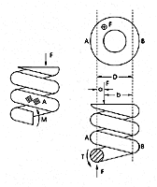
Figure 1. In a spring, the helix converts the linear force to a torsional moment, T, which propagates down the wire and becomes a linear force at the other end. Free-body analysis also shows a parasitic shear and moment, which are not measured with a gauge pair at A. A second gauge at B completes the bridge and gives a measure of the total shear moment.

Mathematics Behind TSLCs
A proprietary development of the GageTek Company, the TSLC is a derivative of the company’s helical load cell. The equations behind the TSLC are derived from the operation of a spring. A spring converts the linear force to a torsional moment in the wire. Generally, loading results in three reactions (see Figure 1):
- The torsional force, T
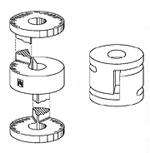
Figure 2. The Torsional Sensing Load Cell is constructed by machining slots in a solid piece of stainless steel, creating a flat spring. The structure gains better side load performance because of symmetry. It also has better dimensional accuracy and stability than ontained from winding wire.

- The loading force, F
- The bending moment, M
The torsional force is the only force of interest in the TSLCs. It results in a strain on the surface on the wire and can be measured by mounting shear pairs at diametrically opposed positions on the spring at A and B.
The load cell is constructed by machining a steel spring (see Figure 2). Instead of the helix, the
sensing area forms a circle with strain gauge pairs mounted in diametrical opposition. A variation of this is the slot block TSLC (see Figure 3), which is the easiest to assemble and has the lowest possible cost. In this design, GageTek has simplified the load cell by removing the upper and lower loading surfaces and building a load cell from a single block of steel with a slot cut into it. In this case, the strain gauges are mounted on one surface of the load cell.
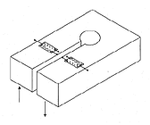
Figure 3. The slot block Torsional Sensing Load Cell (TSLC) is a load cell simplified by removing the upper and lower loading surfaces. The TSLC is made by cutting a slot in a block, as the name implies. The direction of loading is shown by the arrows.

The TSLC is insensitive to off-axis loads because of the way in which the torsion propagates around the
length of the load cell. A free body TSLC diagram (see Figure 4) of the loading results in:
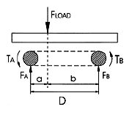
Figure 4. A free-body diagram of a Torsional Sensing Load Cell shows that a torsion is developed in the torsional sensing element (the area between T_{A} and T_{B}) equal to the force times the distance to that section of the element. The combined distance is always equal to the diameter, and thus the total torsion at the two gauged points is proportional the the diameter of the sensing element.

T_{A} | =(F_{LOAD})(a) | (1)
T_{B} | =(F_{LOAD})(b) | (2)
T_{TOTAL} | = (F_{LOAD})(a) + (F_{LOAD}) | (3)
T_{TOTAL} | = (F_{LOAD})(D) | (4)
This analysis shows that the total torsion at the point of application of the strain gauges is equal to the total force multiplied by the effective diameter. It does not depend on the placement of the load. The result is the same for any positional placement of F, the loading force, inside or outside the diameter of the load cell.
F is measured by placing shear pairs on the sensing element in a standard Wheatstone bridge configuration (see Figures 5 and 6). (Note that the element was straightened for purpose of illustration.)
  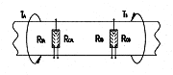
  Figure 5. To measure torsion, two shear pair-type gauges are placed on the surface of the twisting element. One half of each gauge pair is in tension, and the other half is in compression.
  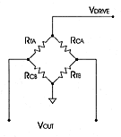
  Figure 6. The Wheatstone bridge is configured by placing the compression (R_{CA}) and tension (R_{TA}) pairs on opposite sides of the bridge.
Placed on the neutral axis of the torsional element, the gauge pairs reject parasitic linear forces and moments, resulting in an output proportional to the total torsion, and so the total load force.
The gauges are placed according to the following rules:
- Gauges can be placed on any point along the circumference of the element, but they should be a mirror image across the diameter or slot (e.g., top-top or side-side).
- Gauges should be placed so the presence of other forces or moments are rejected by the complementary pairs.
- Gauges should be in diametrical opposition to each other across the diameter or slot.
- The structural cross section at the points of application of the gauges should be identical.

Configuring for a Seat
Fitting the load cell to a seat is a simple matter. Seat mounting and slider arrangements fall into two general configurations: vertical rails and horizontal rails. In either case, the base, or feet, of the seat must be isolated from the sliding rails that transport the seat forward and back. This isolation is in the form of a gap separating the two parts.
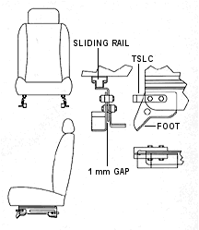
Figure 7. In cars with vertical rail assemblies, the Torsional Sensing Load Cell (TSLC) is configured to cross a gap created by moving each of the feet out 1 mm.

In the vertical rail configuration shown in Figure 7, the feet attached to the chasis are connected to the seat’s sliding mechanism, with horizontal rivets connecting the stamped parts. Moving each foot outward and attaching the TSLC over the ends of the seat assembly creates the isolation gap. The load cells do not interfere with the motorized or manual sliding mechanism of the seat. Because the isolation gap is 1 mm, the base of the seat at the chassis must be made 2 mm wider, or, conversely, the attachments at the base of the seat need to be 2 mm narrower. Load cells can be riveted or bolted into position.
Horizontal rails are handled in similar fashion—1 mm is added to the seat’s height to create the isolation gap. Figure 8 shows two typical configurations. In the first case, the sliding rail is placed on top of the stamped foot, and the load cell is recessed in the foot itself. In the second configuration, the horizontal sliding rail connects directly to the chassis, and the seat attaches to the upper sliding part of the rail assembly. The lower detail in Figure 8 shows how the load cells are placed directly in the seat. The load cell is again protected from abuse because the complete assembly is in the seat structure.
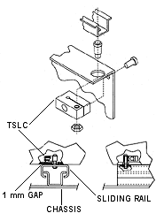
Figure 8. In cars with horizontal rail assemblies, the Torsional Sensing Load Cell (TSLC) is configured to cross a gap created by moving the seat up off the feet by 1 mm. In some assemblies of this type, the load cell can be completely enclosed by the seat itself, protecting the load cell from damage.

In all mounting configurations, having the slot running axially from front to back of the vehicle is desirable because the beam sections can be strengthened for front or rear collision. Strength exceeding 2000 lb. per load cell, or 8000 lb. per seat, is easily achieved. During a side impact, the gap on one side of the seat collapses, and the load cell becomes solid under the compressive load. High loads can be resisted.
The manufacturer can construct load cells so that they can be mounted in other directions. It optimizes the strength by shaping the beam element and rear cross section of the cell to accommodate different loading and impact scenarios.
Construction of the TLSC
A fundamental operating principle of the TSLC is that the output is dependent only on the torsional compliance of the section that incorporates the strain gauges. One of the most important secondary qualities of any seat-based system is the ability to withstand a collision. Another is to provide an electrical signal to the signal conditioner that is large enough to make it distinguishable from noise
introduced into the cabling from other sources inside the vehicle. A large signal eliminates the need for expensive shielded cables traditionally associated with small signal output from foil gauged load cells.
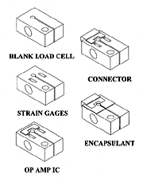
Figure 9. In one proposed construction of the load cell, all operations occur from one side to automate the process and lower construction costs. Gauges, amplification ICs, connectors, and a protective encapsulation are all applied to the complete construction.

To achieve these two qualities, the load cell should have high strain in torsion and low strain in tension, compression, and bending. An I-beam meets these requirements. The manufacturer can construct a simple I-beam without the web simply by drilling a hole through the torsional element perpendicular to the direction of the propagation of the torsion around the element (see Figure 9). It can lengthen the back, or solid end, of the element to provide strength in bending in the horizontal plane. This doesn’t affect the output of the cell. In this way, the manufacturer has constructed load cells with nominal outputs of 1 mV/V at 200 lb. loads that still meet a crash requirement of 35 mph, or ~8000 lb. of force, in the forward direction of the seat without failure.
Additional output can be obtained by using piezoresistive gauge elements. Typically, this type of gauge has a gauge factor of 20, or 10 × the output of a foil gauge. This results in a proportionally higher output obviating the need for a high gain differential amplifier at the output of the bridge.
In one proposed scenario, you have a typical construction of the TSLC for a horizontal seat rail. The simple element is a machined, cast, or stamped element. The manufacturer has applied gauges to the upper surface and bonded an interconnection element to the interconnection points of the gauges. The device could contain an amplification ASIC. The manufacturer has attached a molded connector and then applied an encapsulation layer to protect the assembly.
The result is a rugged, low-cost load cell ready for mounting on the seat rails. Typical specifications for such a load cell are linearity better that 0.1% full scale, with a temperature coefficient of <2% full scale over a temperature range of –20 C to 60 C. The output of a foil-based system is typically 1 mV/V, and a piezoresistive system is 20–100 mV/V.
Centroid Calculation
Because load cells are placed at each corner of the seat, calculation of the center of gravity is as simple as calculating the centroid of the forces at the corners of the seat. The four seat corner forces (F₁, F₂, F₃, F₄) are at fixed and known distances from the center of the seat (see Figure 10). The centroid distance from the center of the seat in the Y direction (l_{Y}) is the sum of these forces multiplied by the distances divided by the total force.
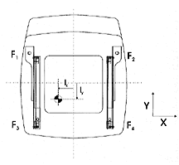
Figure 10. The load cell calculates the occupant position by centroid, measuring the forces on the four corners and weighing the forces with respect to position. The position of the forces at each corner, F₁ through F₄, is fixed with respect to the interior of the vehicle.

Likewise the side position (l_{X}) can be calculated in similar fashion. This calculation provides both the X and Y positions and is appropriate for both front and side air bags.
Ancillary forces are present (see Figure 11) and cause an error in the weight measurement. Generally these error forces come from two sources:
- The force of the occupant’s foot on the floor of the vehicle (FF)
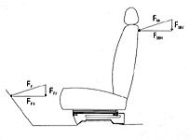
Figure 11. Ancillary error forces on the floor and the seat back are created by the occupant's feet and the hands of the rear seat passenger on the front seat, respectively. These forces are small and generally limited to weight errors in the vertical component of the force vector.

- The force on the front seat back from a rear seat passenger pushing (FSB)
In both cases, these forces resolve into horizontal and vertical components, with only the FSB having an effect on the weight measurement.
Seat belt tension causes another minor error, to the extent of the tension attached to points off the seat. With the TSLC technology, however, tightening the seat belt around a child seat mount does not cause an erroneous signal as with pressure pads because the weight at the feet of the seat is unchanged.
The cost of manufacturing TSLCs depends largely on how the cell element is constructed and the type of strain gauges used. On average, the cost is less than $20 per seat, or $5 per load cell. Approximately 60% of the cost is for the load cell elements and the strain gauges. The remaining 40% is allocated to encapsulation, packaging, and connectors. For example, piezoresistive strain gauges cost more than foil or electro-deposited gauges. The costs are offset by the higher output and the reduced requirement for low-noise instrumentation electronics for analog signal processing.
Conclusion
The torsional sensing load cell is a viable solution to the problem of detecting occupant weight and position for passenger side air bag deployment. Tested on seats in a variety of configurations, these rugged, durable, and accurate load cells can be built to fit virtually any seat construction with minimal impact to existing designs.

